ID : GBE01158

Nama : Zuhair Yahya

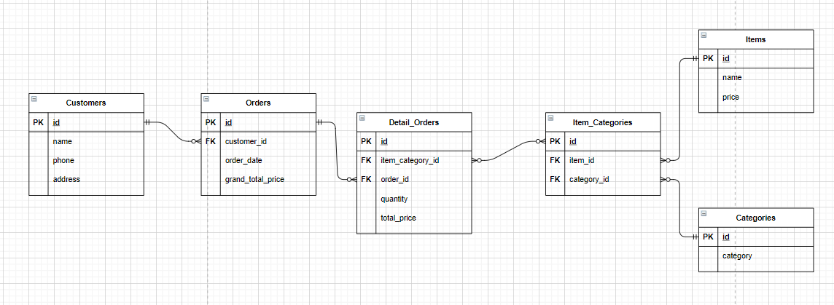

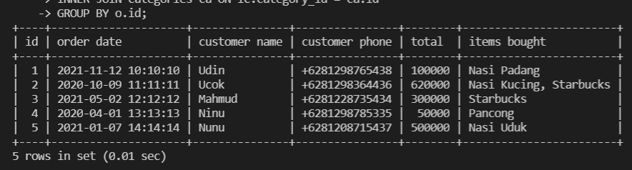

CREATE TABLE items (

id INT NOT NULL PRIMARY KEY AUTO_INCREMENT,

name VARCHAR(255) NOT NULL,

price INT NOT NULL

);

CREATE TABLE categories (

id INT NOT NULL PRIMARY KEY AUTO_INCREMENT,

category VARCHAR(50) NOT NULL UNIQUE

);

CREATE TABLE item_categories (

id INT NOT NULL PRIMARY KEY AUTO_INCREMENT,

category_id INT NOT NULL,

FOREIGN KEY (category_id) REFERENCES categories(id),

item_id INT NOT NULL,

FOREIGN KEY (item_id) REFERENCES items(id)

);

CREATE TABLE customers (

id INT NOT NULL PRIMARY KEY AUTO_INCREMENT,

name VARCHAR(255) NOT NULL,

phone CHAR(12) NOT NULL UNIQUE,

address VARCHAR(255) NOT NULL

);

CREATE TABLE orders (

id INT NOT NULL PRIMARY KEY AUTO_INCREMENT,

customer_id INT NOT NULL,

FOREIGN KEY (customer_id) REFERENCES customers(id),

order_date DATETIME NOT NULL,

grand_total_price INT NOT NULL

);

CREATE TABLE detail_orders (

id INT NOT NULL PRIMARY KEY AUTO_INCREMENT,

item_category_id INT NOT NULL,

FOREIGN KEY (item_category_id) REFERENCES item_categories(id),

order_id INT NOT NULL,

FOREIGN KEY (order_id) REFERENCES orders(id),

quantity INT NOT NULL,

total_price INT NOT NULL

);

INSERT INTO items (id, name, price) VALUES (1, 'Nasi Padang', 20000);

INSERT INTO items (id, name, price) VALUES (2, 'Nasi Kucing', 5000);

INSERT INTO items (id, name, price) VALUES (3, 'Starbucks', 50000);

INSERT INTO items (id, name, price) VALUES (4, 'Pancong', 7000);

INSERT INTO items (id, name, price) VALUES (5, 'Nasi Uduk', 10000);

SELECT id, name, price FROM items;

SELECT * FROM items;

INSERT INTO categories (id, category) VALUES (1, 'Makanan'), (2, 'Minuman');

SELECT * FROM categories;

INSERT INTO item_categories (item_id, category_id) VALUES (1, 1), (2, 1), (3, 2), (4, 1), (5, 1);

SELECT * FROM item_categories;

SELECT items.id, items.name, item_categories.category_id FROM items JOIN item_categories ON items.id = item_categories.item_id;

SELECT categories.*, GROUP_CONCAT(items.name) AS items, MAX(items.price) AS price FROM categories LEFT JOIN item_categories ON categories.id = item_categories.category_id JOIN items ON item_categories.item_id = items.id GROUP BY categories.id;

INSERT INTO customers (id, name, phone, address) VALUES

(1, 'Udin', 081298765438, 'Jakarta'),

(2, 'Ucok', 081298364436, 'Bekasi'),

(3, 'Mahmud', 081228735434, 'Karawang'),

(4, 'Ninu', 081298785335, 'Purwokerto'),

(5, 'Nunu', 081208715437, 'Jambi');

INSERT INTO orders (customer_id, item_category_id, order_date, total_price, quantity) VALUES

(1, 1, '2021-11-12 10:10:10', 100000, 2),

(2, 2, '2020-10-09 11:11:11', 20000, 3),

(3, 3, '2021-05-02 12:12:12', 300000, 10),

(4, 4, '2020-04-01 13:13:13', 50000, 9),

(5, 5, '2021-01-07 14:14:14', 500000, 7);

SELECT * FROM orders o

INNER JOIN customers c ON o.customer_id = c.id

INNER JOIN detail_orders do ON do.order_id = o.id

INNER JOIN item_categories ic ON ic.id = do.item_category_id

INNER JOIN items i ON ic.item_id = i.id

INNER JOIN categories ca ON ic.category_id = ca.id;

SELECT o.id, o.order_date AS 'order date', c.name AS 'customer name', c.phone AS 'customer phone', SUM(do.total_price) AS total, GROUP_CONCAT(i.name SEPARATOR ', ') AS 'items bought' FROM orders o

INNER JOIN customers c ON o.customer_id = c.id

INNER JOIN detail_orders do ON do.order_id = o.id

INNER JOIN item_categories ic ON ic.id = do.item_category_id

INNER JOIN items i ON ic.item_id = i.id

INNER JOIN categories ca ON ic.category_id = ca.id

GROUP BY o.id;

INSERT INTO detail_orders (item_category_id, order_id, quantity, total_price) VALUES

(1, 1, 2, 100000),

(2, 2, 3, 20000),

(3, 3, 10, 300000),

(4, 4, 9, 50000),

(5, 5, 7, 500000);

INSERT INTO orders (customer_id, order_date, grand_total_price) VALUES

(1, '2021-11-12 10:10:10', 200000),

(2, '2020-10-09 11:11:11', 50000),

(3, '2021-05-02 12:12:12', 3000000),

(4, '2020-04-01 13:13:13', 450000),

(5, '2021-01-07 14:14:14', 3500000);

INSERT INTO detail_orders (item_category_id, order_id, quantity, total_price) VALUES

(3, 2, 2, 600000);

SELECT * FROM orders INNER JOIN detail_orders ON orders.id = detail_orders.order_id;

UPDATE customers SET phone='+6281298765438' WHERE id=1;

UPDATE customers SET phone='+6281298364436' WHERE id=2;

UPDATE customers SET phone='+6281228735434' WHERE id=3;

UPDATE customers SET phone='+6281298785335' WHERE id=4;

UPDATE customers SET phone='+6281208715437' WHERE id=5;